Homework #3
Medical Imaging and Robot Instrumentation
D-term 2020
Due 5/8/2020 by 11:59pm EST

Submit scanned or typed copy electronically through Canvas
Please name your pdf file as “HW3_LastName.pdf”

HW #1 is designed to be completed by hand and scanned, or it may be typed.

Question 1: (3points * 8 = 24)
Short questions. Please answer for the following questions.
- Fill in the blank with the appropriate unit
1 ____ = 3.7 X 10 MBq
Bq is SI unit of radioactivity, 1 decay per second
Curie is traditional unit, defined as the activity of 1g of Radium-226, and 1 Ci = 3.7x10^10 disintegrations per second
Answer: 1 milllicurie (mCi)

- In a radioactive decay process, the resulting daughter atom has a higher binding energy per nucleon than the parent atom. True or false?

Answer:

- A desirable property of radiotracers for use in the human body is that they emit alpha particles. True or false?

Answer:

- The equation A_{t} = A₀e^{-λt} is called ______________ law?

Answer:

- Shaping the acoustic beam into a narrower beam than is achieved using a flat vibrating place is called ....

Answer:

- Any sound above _________ is considered to be ultrasound.

Answer:

- An M-mode image is made up of multiple B-mode images. True or false?

Answer:

- By adding separate delays to the receive circuit of each transducer, what capability becomes possible?

Answer:

Question 2: (20points)
Derive the time delay between t_{min} and t_{i} when implementing dynamic receive beamforming on a curvilinear array?
- Please show your work.
- Plot τ vs. i for (0, 5)cm focus, R = 1 cm, and 33-element aperture

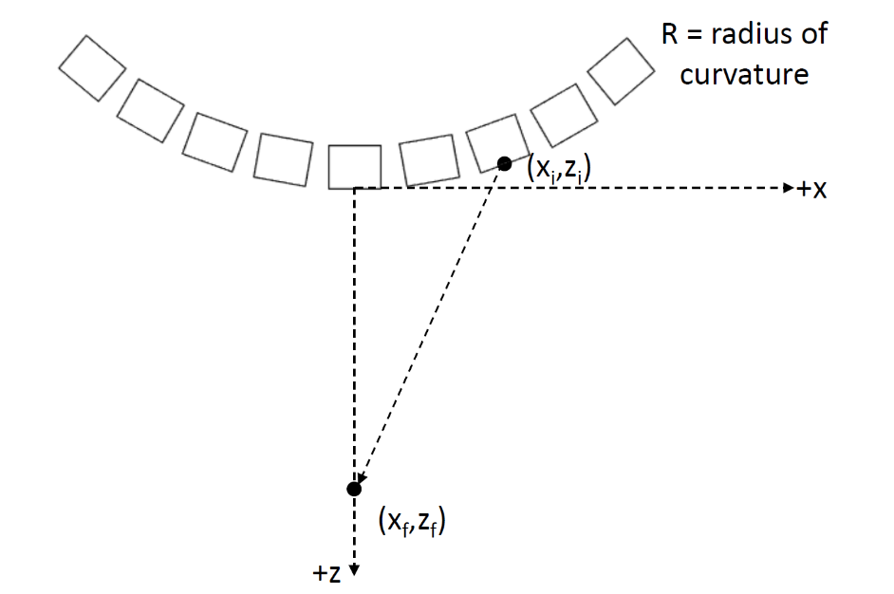

Question 3: (6points*4 = 24points)
A 1cm X 1cm square transducer centered at the origin and submerged in oil is directed toward the +z-axis. An interface between the oil and fat is located at z = 0.1m, assuming normal incidence. The transducer operates at frequency f = 1MHz, with a wavelength λ_{oil} = 1.5 X 10⁻³m. The parameters are: ρ_{oil} = 950 kg/m², a_{oil} = 0.95 dB cm⁻¹ MHz⁻¹, ρ_{fat} = 920 kg/m³, c_{fat} = 1450 m/s.

- What are the reflection and transmission angles?

Answer:

- What is the amplitude reflectivity |R|.

Answer:

- What is the minimum sensitivity L (dB) needed to detect an echo from the interface?

Answer:

- Is the interface in Fraunhofer field? Why?

Answer:

Question 4: (32points + bonus 15points)
This question aims to learn how to use the ultrasound simulation software “Field II” which runs with Matlab.

Preparations
- Download Matlab
- Download a brief introduction here.
- Download materials here
- See the detailed explanation of Field II here if you are interested.

- (6pt) Read the introduction and complete the Delay-and-Sum beamforming (DAS.m)

Answer:
Line 14: depth =
Line 15: width =
Line 16: distance =

- (6pt) Show the reconstruction image by using the completed DAS beamforming

Answer:
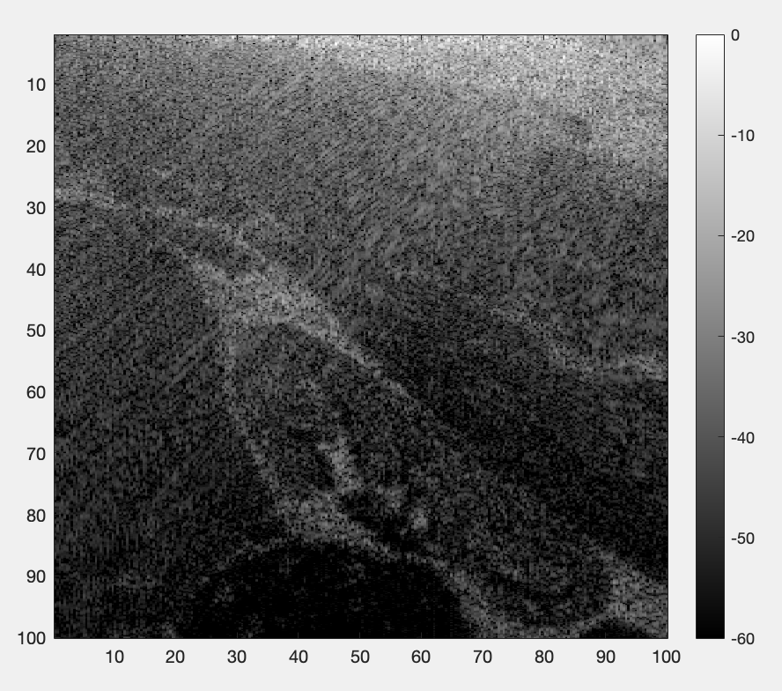
- (5pt) Change the number of elements from 256 to 128 and show the reconstruction image

Answer:
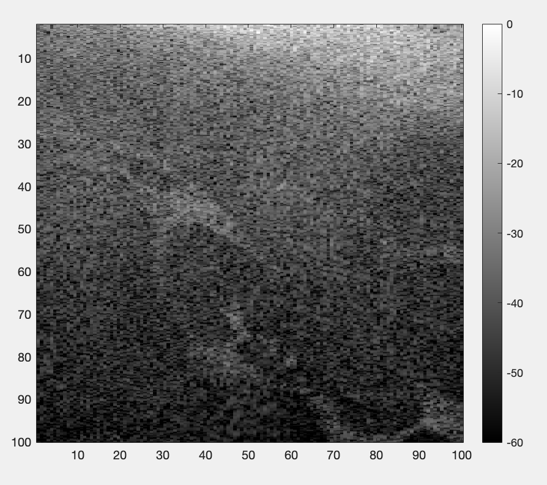
- (5pt) Change the number of elements from 256 to 512 and show the reconstruction image

Answer:
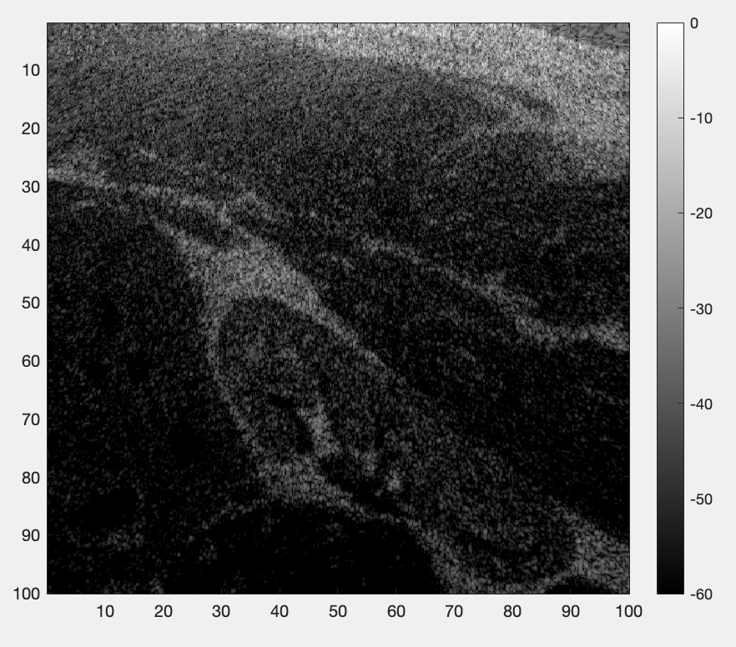
- (5pt) Describe the role of sampling frequency in the RF data generation/image reconstruction (line 6 in imageGen_256, line 23 in sim_kidney_linear_array_256.m)

Answer: Tells Field II how often to record the returning echo signal per second
At 40 MHz, Field II records 40 million samples per second
Higher Fs = more data points recorded – finer detail captured
Must satisfy Nyquist theorem: Fs must be at least 2x the transducer center frequency (f0 = 2MHz), so 40MHz is well above this
Controls the axial sampling density of the raw RF data

Told in image reconstruction: converts sample numbers into physical distances, this is used to calculate the depth axis of the image
Used in DAS to convert time delays into physical distances
If Fs is wrong or mismatched between generation and reconstruction, the depth scale will be incorrect

Fs higher – better axial resolution, larger file sixes, slower simulation
Fs lower – coarser axial resolution, risk of aliasing
Mismatched between scripts – image depth appears stretched or compressed

- (5pt) Describe the role of Hilbert transformation in the reconstruction (line 19 in ImageGen_256.m)

Answer:
After DAS beamforming, out is a raw RF signal, looks like oscillating waves, oscillates positive and negative around zero, hard to display as an image because it contains both positive and negative values, oscillation frequency is the transducer center frequency.
The Hilbert transform works in three steps – converts real RF signal to complex analytic signal, (Hilbert(out) complex signal = real part + imaginary part, then step 2 : abs() extracts the envelope smooth envelope curve, and then the result looks like a smooth, almost always positive

Overall : smooth amplitude envelope, always positive, ready for display, shows reflector strength rather than carrier frequency

Hilbert transform converts the oscillating RF signal into a smooth envelope that can be displayed as a recognizable grayscale ultrasound image

- (Bonus: 5points) Write the code of quantifying the resolution of a point target. “validation_linear_array.m” which includes point targets can be used for testing your code. Please show the process and result.

Answer:

- (Bonus: 10points) Delay-Multiply-and-Sum (DMAS) is one of the state-of-the-art beamforming methods. Read the following paper and create the DMAS algorithm based on the DAS.m. Show the reconstruction image as the answer. Please compare the resolution between DMAS and DAS algorithms.
Paper: https://ieeexplore.ieee.org/document/6960091
Hint: implement eq. (2)-(4) in the paper

Answer: